FOR IMMEDIATE RELEASE

Media Contact: Barry Rabkin | Chief Marketing Officer | Identified Technologies | 412.760.3308 | PR@IdentifiedTech.com

Company Address: 6534 Hamilton Ave, Pittsburgh, PA 15206 USA

Entrepreneur Magazine Names Identified Technologies a “Brilliant 100 Company - Top 10 Tech Companies to Watch”
Pittsburgh Drone Startup Sits Among Silicon Valley Heavyweights

June 17, 2016, Pittsburgh, PA- Identified Technologies has been named an Entrepreneur Magazine ’Brilliant 100 Company’ and one of the publication’s ‘Top 10 Tech Companies to Watch’ for 2016.

Each year, Entrepreneur compiles its Brilliant 100 list by selecting the ideas, companies, applications and innovations that have unique solutions to common problems or marketplace voids. For 33 years, the publication has been the definitive guide to all the diverse challenges of business ownership.

Identified Technologies shares the honor with companies such as Ubeam and Magic Leap, who have raised $23M and $1.39B respectively. “It is thrilling to have our name alongside some of the largest startups in the United States” said Zhang, “It shows that major outlets are taking notice of the technology we are creating here in Pittsburgh.”

Previously job site data had to be gathered slowly by hand. Entrepreneur chose Identified Technologies for its Boomerang aerial mapping drone and SiteIQ system. The startup’s unique robotics and data analytics tools allow industrial companies to automatically gather construction project progress in minutes instead of months, for continuous insights that reduce costs, injuries, and delays.

“We have built a very talented and dedicated team here at Identified Technologies. This recognition is a reflection of all of their hard work and commitment to build a product that best serves our ever-growing client base,” said Identified Technologies CEO Dick Zhang.

Identified Technologies has found its market niche in using self-piloting drones to quickly and accurately perform near real-time aerial site mapping and monitoring that traditionally has been done by manned helicopters and fixed-wing aircraft, or ground level survey crews. These expensive or slow options often forced companies to risk using outdated and inaccurate information.
Zhang founded Identified Technologies in 2013 while studying mechanical engineering at the University of Pennsylvania, where he was involved with the school’s General Robotics, Automation, Sensing and Perception Laboratory and its research into small unmanned aerial vehicles. The company won Penn’s Y-Prize Business Plan Competition in 2013 after developing a software and hardware platform based off SUAVs. Zhang moved to Pittsburgh in late 2013after being accepted into AlphaLab Gear’s inaugural class.

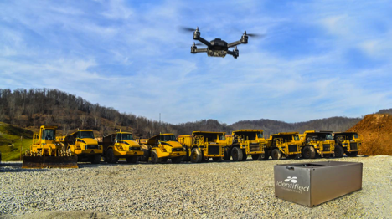

Since then, Zhang has raised 3.5 million in funding led by Birchmere Ventures, partnered up with industry leaders like EQT and P.J. Dick and been selected as a Pittsburgh Business Times Fast Tracker, Ernst and Young Entrepreneur of the Year Finalist, Pittsburgh TECH 50 ‘Start Up of the Year’ Finalist, SXSW 2015 Enterprise and Smart Data Technologies Finalist, and a Finalist in the ‘New Technology Development – Product’ category for the 2016 Northeast Oil & Gas Awards.
Zhang credits the support of Alphalab Gear, Innovation Works, Birchmere Ventures, Carnegie Mellon University, and the region’s entire entrepreneurial ecosystem for the success of Identified Technologies.

“All that we have accomplished can be traced to the support and collaborative approach of Pittsburgh’s start-up community. We are grateful to be a part of it,” said Zhang.

About Identified Technologies

Pittsburgh, PA-based Identified Technologies provides aerial monitoring, measuring and mapping for industrial, construction, mining and energy job sites. The company’s proprietary drone package updates site data 60 times faster than traditional methods. IDTech’s mission is to deliver Big Insights for Big JobsTM using its innovative robotic system that includes the self-piloting BoomerangTM drone and its companion LaunchPadTM SmartDock.

