FOR IMMEDIATE RELEASE
Media Contact: Barry Rabkin | Chief Marketing Officer | 412.760.3308 | PR@IdentifiedTech.com
Sales Contact: Identified Technologies | 412.307.5174 | Contact@IdentifiedTech.com
Company Address: 6534 Hamilton Ave, Pittsburgh, PA 15206 USA

PGH Construction Drone Startup Selected as Finalist
For Prestigious Fourth Annual Northeast Oil & Gas Awards

Honor Recognizes Time and Money Saving Aerial Tracking Technology

February 9th, 2016, Pittsburgh, PA- Identified Technologies has been named a finalist in the ‘New Technology Development – Product’ category for the annual Northeast Oil & Gas Awards.

Identified Technologies use their Proprietary Boomerang mapping drones to automate the 3-D surveying and monitoring of construction job sites. They’ve been expanding quickly throughout the energy sector, for applications including pipelines, aggregate piles, drilling, excavation, and impoundment ponds.

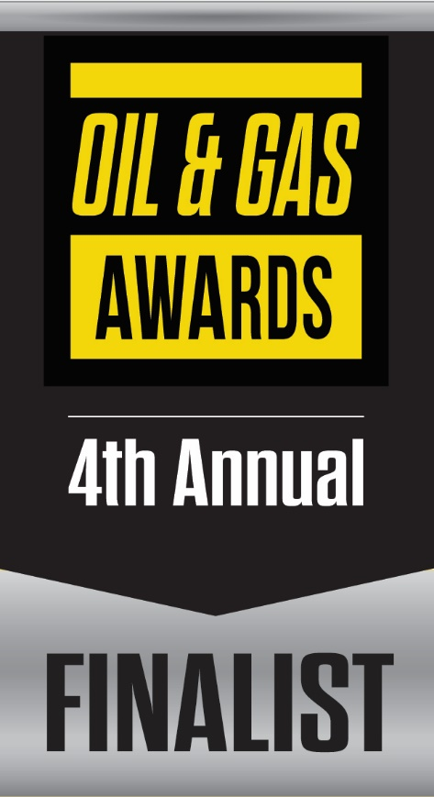

The Oil & Gas Awards recognize outstanding achievements made within the upstream and midstream sectors of the North American oil and gas industry. Entrants in the competition are judged by a distinguished panel of oil and gas industry leaders. Winners will be announced at the Northeast Oil & Gas Industry Summit and gala dinner on Wednesday, March 30, 2016 at the Westin Convention Center Hotel in Pittsburgh.

“I am grateful to accept this recognition on behalf of our talented and dedicated family at Identified Technologies. It is a blessing to work with such a gifted and positive team,” said Identified Technologies CEO Dick Zhang.

Identified Technologies has found its market niche in using self-piloting drones to quickly and accurately perform near real-time aerial site mapping and monitoring that traditionally has been done by manned helicopters and fixed-wing aircraft, or ground level survey crews. These expensive or slow options often forced companies to risk using outdated and inaccurate information, resulting in costly mistakes and miscommunications. Now their clients enjoy faster, more efficient work, thanks to near real-time precision progress updates securely available for all project stakeholders

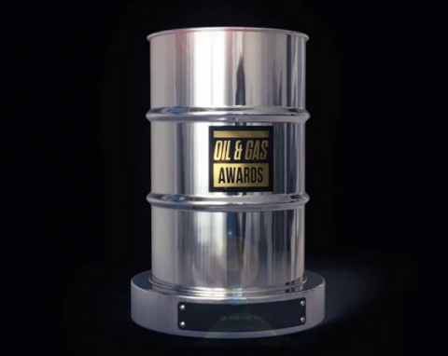

The Oil & Gas Awards are a platform for the oil and gas industry to demonstrate and celebrate the advances made in the key areas of environment, efficiency, innovation, corporate social responsibility, and health and safety. They showcase the industry’s motivation to develop by recognizing and rewarding the efforts of companies and individuals.
Zhang founded Identified Technologies in 2013 while studying mechanical engineering at the University of Pennsylvania, where he was involved with the school’s General Robotics, Automation, Sensing and Perception Laboratory and its research into small unmanned aerial vehicles. The company won Penn’s Y-Prize Business Plan Competition in 2013 after developing a software and hardware platform based off SUAVs. Zhang moved to Pittsburgh in late 2013 after being accepted into AlphaLab Gear’s inaugural class. Since then, Zhang has been selected as a Pittsburgh Business Times Fast Tracker, Ernest and Young Entrepreneur of the Year Finalist, a Pittsburgh TECH 50 ‘Start Up of the Year’ Finalist and raised over $2 million in venture capital funding.
Zhang credits the support of Alphalab Gear, Innovation Works, Birchmere Ventures, Carnegie Mellon University, and the region’s entire entrepreneurial ecosystem for ID Tech’s success.

“None of what we have achieved would have been possible without the Pittsburgh start-up community. We are thankful to be a part of it,” said Zhang.
Identified Technologies has grown to more than a dozen full-time employees and moved out of AlphaLab Gear’s accelerator to its present location near Bakery Square last April.
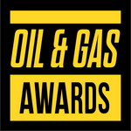
Complete list of finalist companies in the Fourth Annual Northeast Oil & Gas Awards:

Accent Compliance
Alex E. Paris Contracting Co. Inc.
Antero Resources
ARM Group Inc.
Baker Hughes
Bilfinger Westcon
Blank Rome LLP
CASCO USA
CDM Resource Management LLC
Chemplex Solvay Group
CIANBRO
Civil & Environmental Consultants, Inc.
Columbia Midstream
Command Energy Services Ltd.
Crescent Drilling & Production
E-Finity Distributed Generation
Eclipse Resources
EdgeMarc Energy
EQT Corporation
Fortis Energy
Hippo USA
Hodgson Russ LLP
HWD
Identified Technologies
Impact Environmental
Jared Oehring - U. S. Well Services
Kessel
Keystone Clearwater Solutions, LLC
M3 Midstream Energy Company
McCutcheon Enterprises, Inc.
McKim & Creed
Minnesota Limited, LLC
Mustang Oilfield Services, LLC
Myers Well Services
National Fuel Gas Midstream Corporation
O-Ring
OmniCert
Pickering Associates
Pixel Velocity Inc.
Preston Contractors
Puls Incorporated
Rain for Rent
Richard Weber - PennEnergy Resources, LLC
Scientific Drilling International
Select Energy Services
Shalewater Solutions
Sourcewater, Inc.
Steptoe & Johnson PLLC
Tejas Gosai - Shale Media Group
TekSolv
The Gateway Engineers, Inc.
Top Hand Training
U.S. Well Services, LLC
Weatherford International
Well Master

For further information about the Fourth Annual Northeast Oil & Gas Awards please visit:

http://www.oilandgasawards.com/northeast-2016/

Contact:
info@oilandgasawards.com
T: +1 210 591 8468

About the Oil & Gas Awards

The Oil & Gas Awards recognize the outstanding achievements made within the upstream and midstream sectors of the North American oil and gas industry. The Awards are a platform for the industry to demonstrate and celebrate the advances made in the key areas of environment, efficiency, innovation, corporate social responsibility and health and safety. The Awards show the industry’s motivation to develop by recognizing and rewarding the efforts of corporations and individuals. For more information about the Oil & Gas Awards visit the website: www.oilandgasawards.com

About Identified Technologies

Identified Technologies is putting an end to late and over budget construction projects, by giving managers continuous job site visibility to empower fast informed decisions. Leased Boomerang smart drone mapping systems save time and money by allowing updates to be automatically tracked and securely shared with stakeholders in near real-time.

CNN, NBC, Inc, Marcellus Drilling, Oil and Gas 360, Petro Global News, Power Source, Shale Gas international, and the TransTech Energy Conference have featured the company for their precision 3-D project maps captured 200x faster than leading alternatives. This speed and accuracy is enabled by the fully integrated, drone based, end to end data scanning, capture, access, and analytics solution. The Boomerang™ drone flies itself above job sites, captures the mapping data, and lands itself back on the LaunchPad™ dock station, which lives on the client site throughout the project. The dock station then sends the data to the cloud for processing and customer analysis, and swaps and charges the drone's batteries.

The turnkey autonomous solution allows for rapid adoption and scaling across distributed job sites around the world. Identified Technologies growing team is united in our mission to bring big insights to big jobs, with innovative robotic systems.

Website: http://www.identifiedtech.com/

Press Kit: http://www.identifiedtech.com/pr/

