FOR IMMEDIATE RELEASE
Media Contact: Barry Rabkin | Chief Marketing Officer | 412.760.3308 | PR@IdentifiedTech.com
Sales Contact: Identified Technologies | 412.307.5174 | Contact@IdentifiedTech.com
Company Address: 6534 Hamilton Ave, Pittsburgh, PA 15206 USA
PGH Industrial Drone Startup Helps Agora Students Aspirations Take Flight
Robotics Create Rewarding New Career Opportunities for Pittsburgh
February 4, 2016, Pittsburgh, PA - “It’s hard to play with an aerial drone and not get excited about the potential. I’m thrilled that we get the chance to pass our love of science and robotics on to the next generation.” said Dick Zhang, CEO of Pittsburgh based startup, Identified Technologies.
On Thursday January 14, a large group from Learning to Lead and the Agora Cyber Charter School gathered at Identified Technologies HQ, to learn about their future in the skies. Company leaders explained how they used computing, engineering, robotics, and marketing theory to keep their business rising.
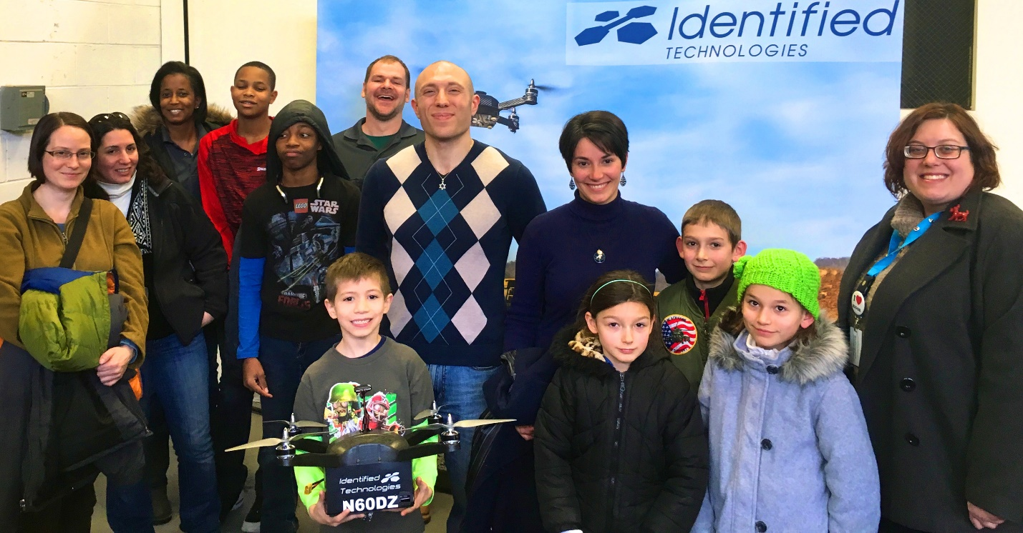
*Identified Technologies CMO Barry Rabkin behind Austin holding drone, with Scott Feely Agora Cyber Charter School Community Coordinator on left
“I really liked the drones! They seem like they have a lot of fun at work.” said Austin, an elementary school student from Agora picturing holding the Boomerang mapping drone. What was once an industrial warehouse has been renovated in to a home for the fastest growing drone startup on the east coast. “All of us are trying to take this company to new heights and our open office helps speed up our communications and bring us all closer together.” said Zhang.
Founded in 2013 by Zhang, Identified Technologies has hand-picked many of the brightest stars from Carnegie Mellon’s robotics department. Their Mission? To develop a self-piloting Boomerang drone system which can map a 100 acre construction site in under 10 minutes vs 1-2 months for a manned survey team. The Boomerang drone achieves 99.6% accuracy compared to traditional surveying models. This grants centimeter grade accuracy in a small fraction of the time.
CTO, Steven Blass said “We are proud of what we have built here, and we work hard every day to stay on the cutting edge of drone mapping.” Coming off of a $2 million funding round from Birchmere Ventures, major industrial customers from around the country are taking notice and taking to the skies.
When asked why they reached out to Identified Technologies, Learning to Lead’s director Beth Mooney said, “We are helping high school students develop the core values that will guide them in making great lifelong decisions. Identified Technologies team embodies the exact same innovation, responsibility and empowerment that we are fostering in our students. Getting to meet their leaders inspires the kids to work harder, feel more hopeful about their futures, and increases their drive to do well in school.”
Scott Feely, the Community Coordinator for the Agora Cyber Charter school spoke about helping students see the cutting edge careers that their educations were opening up for them. “We wanted to bring our students over to see the exciting jobs they can do when they grow up. Identified Technologies is proof that you can have fun, be creative, and make a big impact on your industry, if you’re willing to study and work hard. I think our students were all ready to sign up to join the Identified Technologies team.”
Zhang said, “It was a pleasure hosting Agora, and it was a powerful reminder how lucky we are to get to feel like kids every day. Sometimes it is hard for me to believe that we actually get paid to play with robots!”
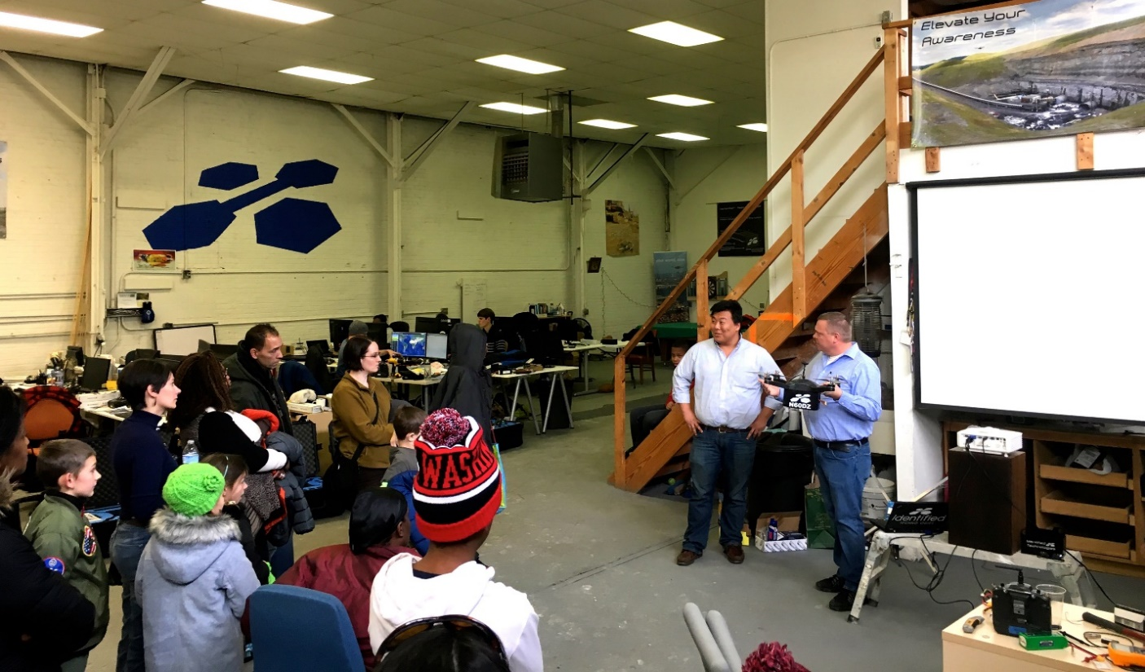
*Identified Technologies CEO Dick Zhang on the left, and Chief Pilot Jon Little Holding Boomerang Drone

“I’ve learned a great deal from mentors in the Pittsburgh startup community, and I’m happy to do my part in giving back. I believe that students can learn a lot from local Pittsburgh companies, and I’m sure we can learn just as much from them. Pittsburgh has always been a city of creation, and as we continue to grow we’re going to need all the gifted, curious minds we can get. Nothing would make me happier than if we inspired some of these bright young men and women to study technology, so when they graduate they can take to the skies with us.”

About IDENTIFIED TECHNOLOGIES
Identified Technologies is putting an end to late and over budget construction projects, by giving managers continuous job site visibility to empower fast informed decisions. Leased Boomerang smart drone mapping systems save time and money by allowing updates to be automatically tracked and securely shared with stakeholders in near real-time.
TechCrunch, Tedx, NBC, CNN, Inc, UAS Magazine, and the Builder Construction Network have featured the company for their precision 3-D project maps captured 200x faster than leading alternatives. This speed and accuracy is enabled by the fully integrated, drone based, end to end data scanning, capture, access, and analytics solution. The Boomerang™ drone flies itself above job sites, captures the mapping data, and lands itself back on the LaunchPad™ dock station, which lives on the client site throughout the project. The dock station then sends the data to the cloud for processing and customer analysis, and swaps and charges the drone’s batteries.
The turnkey autonomous solution allows for rapid adoption and scaling across distributed job sites around the world. Identified Technologies growing team is united in our mission to bring big insights to big jobs, with innovative robotic systems.
Website: http://www.identifiedtech.com/
Press Kit: http://www.identifiedtech.com/pr/

About AGORA CYBER CHARTER SCHOOL
Agora Cyber Charter School is a tuition-free public virtual charter school serving approximately 8,500 Pennsylvania students in Kindergarten through 12th grade under the authorization of the Pennsylvania Department of Education. Agora Cyber Charter School inspires students to reach their highest levels of academic achievement that complements their learning style. Through an individualized learning plan using an innovative content delivery system, the proprietary Agora NextGen curriculum is driven by personalization, performance and early intervention. For additional information call 844-40-AGORA or visit www.Agora.org.

# # #

